**GeekTeches GM328B Transistor tester**

**一 Characteristic**

1. The processor uses high performance single chip ATmega328 and using external 8MHz oscillator as the system clock.
2. 1.8 Inch LCD screen，Resolution is 128X160，Support 65536 colors.
3. Single button operation，Support for automatic shutdown to reduce power consumption.
4. Power supply support battery， the current is less than 20nA when the system is turned off.
5. Measurement time of about 2S each time. Measuring time becomes longer when measuring capacitance or inductance.
6. Detection of NPN or PNP Bipolar Transistor automatic,N channel、P channel MOSFET and JFET,diode,Double diode,P-IGPT,Thyristor、Double thyristor etc. For some thyristor and double thyristor. Unable to test When the transistor tester can not meet the requirements of its trigger current and keep the current. Transistor testers are also unable to test the IGPT drive voltages is over than 5V.
7. Support identification pin for test element.
8. Support test current amplification factor for bipolar transistor and base emitter turn-on voltage.
9. Can judge Darlington transistor through the turn-on voltage and the current amplification factor.
10. Support test the gate threshold voltage of MOSFET、grid capacitance and drain electrode in the case of 5V gate voltage- source resistance RDSon
11. Supports the simultaneous measurement of two resistors,Data is four decimal format display. Support potentiometer test，It can not distinguish between the middle pin and this pin When the potentiometer is adjusted to one end of the potentiometer.
12. Minimum resistance resolution 0.01 ohm, Maximum resistance 50M ohms.
13. Can measure a capacitor, Capacitance range 25pf~100mF, Resolution 1pF.
14. Capacitance less than 25pF can be measured by parallel connection another known capacitor is greater than or equal to 25pF.The measured capacitance value can be obtained by subtracting the known capacitance value from the result.
15. When the test capacitance is greater than 90nF，it series equivalent resistance is also be shown，resolution is 0.01 ohm.
16. When the test capacitance is greater than 5000pF. Voltage loss after the test pulse is can be measured.This parameter can estimate the quality factor of the capacitor.
17. Support two diodes to be measured simultaneously and display voltage drop for diode .
18. LED will be identified as a diode, the test voltage drop is much larger than that of the common diode. Two colors diodes are identified as two diodes.
19. Resistance less than 2100 ohm, it’s equivalent inductance is also measured at the same time. Range is 0.01mH~20H, but it’s measurement accuracy is not very good.
20. Program tape self checking function, Support calibration of multiple parameters.
21. Support frequency measurement function,frequency signal input from PD4 pin. Frequency resolution is 1Hz when the input frequency is greater than 25KHz. When the value is less than that, by measuring the period, the frequency resolution can be 0.001Hz.
22. Support frequency generator function, output by TP2, the output frequency range is 1Hz ~ 2MHz.
23. Support a fixed frequency signal output from the TP2, the duty cycle can be adjusted by the button.

**Particular attention:**

* Be sure to discharge the capacitor before the test capacitance, otherwise it may damage the test pin.
* Be sure to disconnect the power from the circuit board when testing the components on the circuit board, the test equipment have residual voltage is not allowed.

**direction for use**

1. **Component placement**

**Use for Transistor tester is very simple,** **Test pin TP1, TP2, TP3 regardless of successively.** **Only two pins of the component need to be placed into any of the two test pins to be tested.** **Three pin components in random order place three test pins to carry out the test,** **it can simultaneously test two resistors and two diodes.**

**2、Boot**

Press S2 to boot after the power supply is switched on, Boot screen as follows:

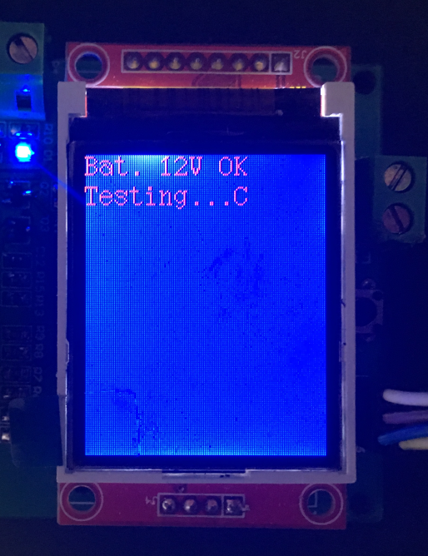 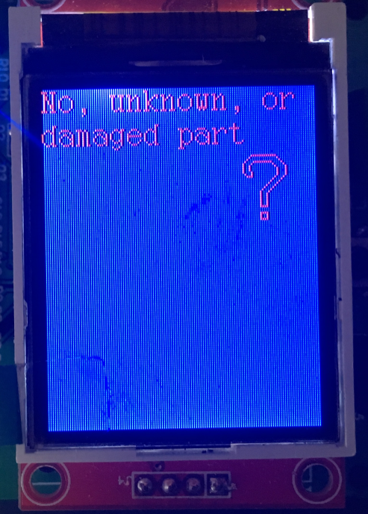

**picture 2-1 Display voltage and start to measur picture 2-2 View of no device to be tested**

**3、LCD display test results ,display test results with Icon, it can distinguish different devices.** **For example,** **display effect of triode as follow(Background and foreground can be configured.):**

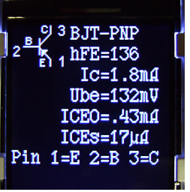

**4、When the following picture was appeared.According to the prompt calibration circuit or press the reset button to turn off.** **Press S2 to restart the new measurement.**

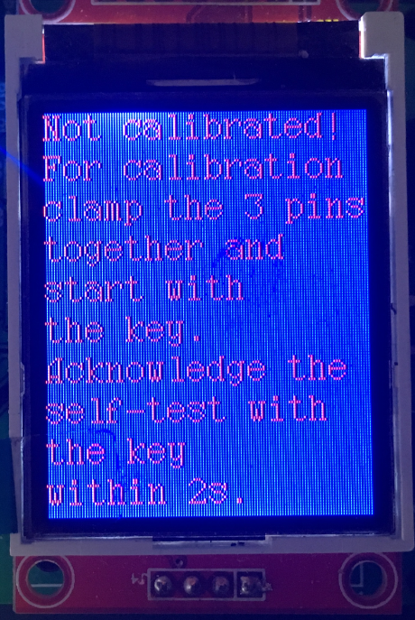

**5.Long press the button more than 1** **second after the boot,** **to** **enter interface of additional function selection.** **After the short button to move the cursor up and down,** **then long press the button，to entering attachment function interface that corresponding to the cursor.** **Each function is described as follows:**

* frequency：Frequency measurement function,Frequency signal input from the PD4 pin. When the input frequency is greater than 25KHz, frequency resolution is 1Hz. When this value is less than that，frequency resolution can be 0.001Hz by measuring period.
* f-Generator: Frequency generator function,output by TP2，The output of frequency range is 1Hz to 2MHz.
* 10-bit PWM: A fixed 7812.5Hz frequency signal output from the TP2, it’s can adjust duty cycle 1% by short pressing the button , adjust duty cycle 10% by long pressing the button.
* C+ESR@TP1:3：Test capacitance value between the TP1 and the TP3 test pins, the result is equivalent input resistance. It can measure continuously if capacitance range is 2uF~50mF.Long press the button to return to the menu interface
* Resistor meter：Resistance measurement；
* Capacitor meter：Capacitance measurement；
* C(uF)-correction：Setting large capacitance calibration parameters, the output result value is the actual measured value plus or minus a certain proportion coefficient, this coefficient is the calibration coefficient.( Warning: Don’t change at will unless you already have a deep understanding of this function)
* Selftest：Self checking function.Complete the self checking function according to the prompt.
* Show data: Shows some of the calibration parameters used in the corresponding software version
* Transistor：Test transistor.
* Switch off: Enter to power off immediately.