INTRODUCTION

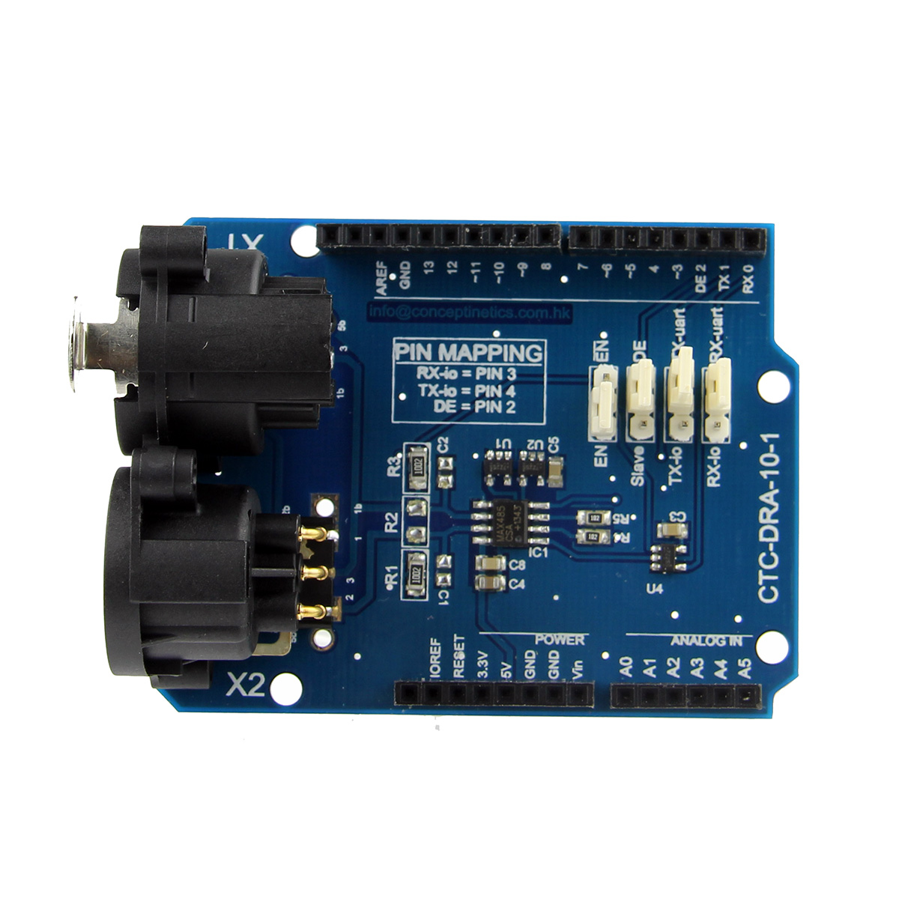
The DMX-shield is an add-on (or "shield") for the Arduino. It is an easy way to use the Arduino as a DMX-Master device, just by adding the DMX-shield on the top of the Arduino.

This DMX / RDM Shield is a low cost high quality solution that allows you to connect your Arduino driven artwork into DMX512 networks. The shield is populated with high quality NEUTRIK XLR 3pin Connectors (1x male and 1x female). The MAX485 based shield can be used as DMX Master, Slave and as RDM transponder.A unique RDM device id will be handed out from out range to you as well, this will make your device worldwide unique.

The following settings are configurable via the onboard jumpers:
- Send data via TX or Digital pin 4
- Receive data via RX or Digital pin 3
- Hardware slave mode or Software Controlled Slave/Master via Digital pin 2 (Required for RDM)
- Enable / Disable shield
In case you have the shield configured to use the RX and TX pins you have to disable the shield before you can upload your new sketch onto the Arduino board. This jumper allows you to disable the shield without disconnecting it from the Arduino board which saves time.

SPECIFICATION
- Remote Device Management
- DMX Master
- DMX Slave
DOCUMENTS
- DMX Library
- Arduino Playboard - DMX
- DMX Library and wiki page (sourceforge)
- User manual

