9.7inch e-Paper HAT

Note
9.7inch e-Paper is big size screen, the glass panel and FPC is fragile, please be careful when use it for developing. we recommend you to reinforce the FPC with scotch tape when developing. Please connect all the cables before powering the device, the device cannot support hot-plug.

Introduction
9.7inch E-Ink display HAT for Raspberry Pi, 1200×825 resolution, 16 gray scale, USB/SPI/I80/I2C interface

Features
- No backlight, keeps displaying last content for a long time even when power down
- Low power consumption, basically power is only required for refreshing
- Compatible with Raspberry Pi Zero/Zero W/Zero WH/2B/3B/3B+
- USB/SPI/I80/I2C interface, for connecting with host boards like Raspberry Pi/Nucleo, etc.
- Comes with development resources and manual (examples for Raspberry Pi/STM32)

Specifications
- Operating voltage: 5V
- Interface: USB/SPI/I80/I2C
- Outline dimension: 218.8mm × 156.425mm × 1.15mm
- Display size: 202.8mm × 139.425mm
- Dot pitch: 0.169 × 0.169
- Resolution: 1200 × 825
- Display color: black, white
- Gray scale: 2-16 (1-4 bit)
- Full refresh time: <1s
- Total refresh power: 0.6W(typ.)
- Total standby power: 0.3W(typ.)
- Viewing angle: >170°

Working principle
This product is an E-paper device adopting the image display technology of Microencapsulated Electrophoretic Display, MED. The initial approach is to create tiny spheres, in which the charged color pigments are suspending in the transparent oil and would move depending on the electronic charge. The E-paper screen display patterns by reflecting the ambient light, so it has no background light requirement.Under ambient light, the E-paper screen still has high visibility with a wide viewing angle of 180 degrees. It is the ideal choice for E-reading.(Note that the e-Paper cannot support updating directly under sunlight)

How to use

Working with Windows PC
- Connect 9.7inch e-paper to IT8951 driver board as below
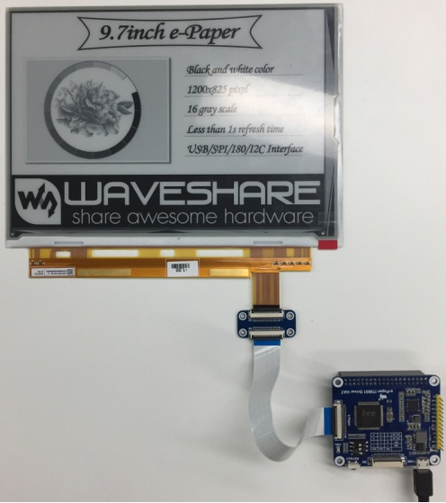
- Connect driver board to PC by USB cable
- Download and open test software E-LINK-TCON-DEMO
- Click connect as below
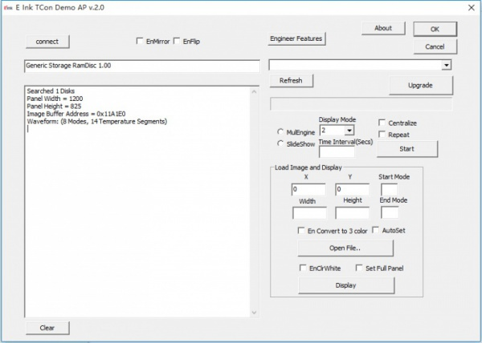
- Check option "AutoSet", then click "Open File" to open one picture for display. Browse diagram will be opened, and you should click "OK"
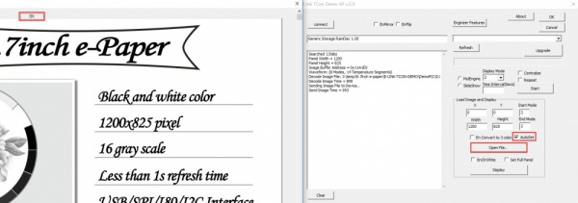
- Click "display" to refresh the picture
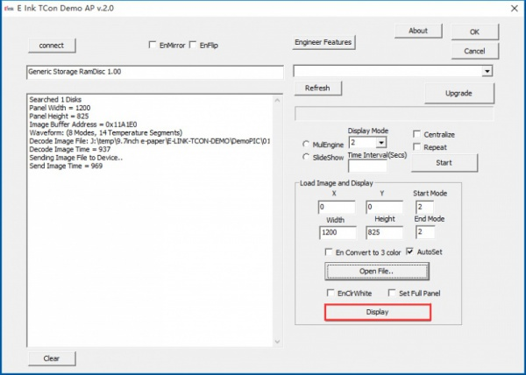

Working with Raspberry Pi
- Hardware connection
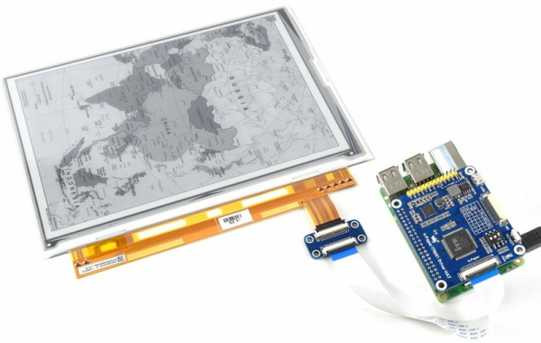
You can also connecting by wires
Connect to Raspberry Pi via SPI
IT8951 Driver HAT | Raspberry Pi (BCM) | Description'
5V | 5V | 5V power input
GND | GND | Ground
MISO | P9 | MISO Pin of SPI
MOSI | P10 | MOSI Pin of SPI
SCK | P11 | SCK Pin of SPI
CS | P8 | Chip selection of SPI (Low active)
RST | P17 | Reset pin (Low active)
HRDY | P24 | Busy stats pin (Low when busy)
- Make sure you have switched the sail switch to SPI mode
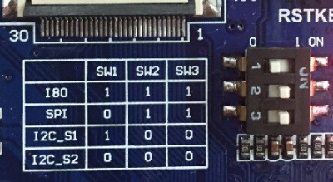
- Install BCM2835 libraries to your Raspberry Pi, you can download the newest bcm2835 library from its official website http://www.airspayce.com/mikem/bcm2835/
Copy the library you download to Raspberry Pi and install it withe commands below. You can also following the instruction on its website above
tar zxvf bcm2835-1.xx.tar.gz
cd bcm2835-1.xx
./configure
make
sudo make check
sudo make install
- Download Demo code and copy to your Raspberry Pi. Extract and run it with the commands below in your Raspberry Pi
tar zxvf IT8951.tar.gz
cd IT8951
make clean
make
sudo ./IT8951 0 0 01.bmp
This demo code supports display general BMP pictures directly, if you find that your BMP picture cannot be displayed, please open it on Windows PC with Paint software (Windows APP), save as BMP and try again.
The command ;./IT8951 0 0 01.bmp', the first two parameters is X and Y coordinate of picture's left-top, 01.bmp is the file name of picture

Working with STM32
Because IT8951 will cost big size of RAM, some of STM32 cannot support without external SDRAM device. So we here use Open429I as test board, Open429I integrates IS42S16400J (64-MBIT) SDRAM,has full memory to drive the 9.7inch e-paper.
Working with STM32, you can use SPI, I80 or I2C interface. SPI is simple and need a few of GPIO, its speed can also meet the requirement of most applications. I80 is also simple and fast, however, it need to use lots of GPIO. I2C is every slow, which we don't recommend.
SPI
1) Hardware connection
IT8951 | STM32 | Description
5V | 5V | 5V Power input
GND | GND | Ground
MISO | PE13 | Data output
MOSI | PE14 | Data input
SCK | PE12 | Clock input
CS | PE11 | Chip select (Low active)
RST | PC5 | Reset (Low for reset)
HRDY | PA7 | BUSY state output (Low for busy)
2) Set the switch to SPI mode
3) Download demo code to refresh picture
You can download the demo code here
Open the project with keil :Open429I-C-IT8951-Demo\Project\9.7-IT8951\MDK-ARM\Project.uvproj
Compile it, then open IT8951.h, check if SPI mode is enabled. Compile it again and download to your board. After downloading, the
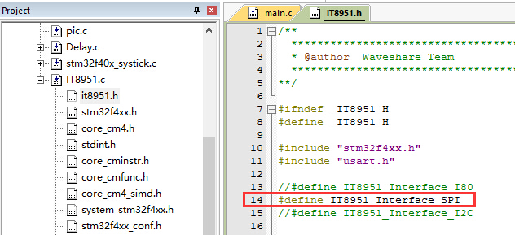
The information will be printed as below (115200, 8N1)
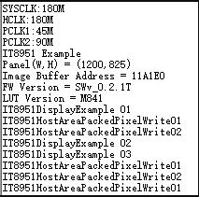
I80
1） Hardware connection
IT8951 | STM32 | Description
Vcc | 5V | 5V Power input
GND | GND | Ground
DBUS0~DBUS15 | PB0~PB15 | Data pins
HWE | PC1 | Write enable (Low active)
D/C | PC7 | Data/Command (Low for command)
CSEL | PC6 | Chip select (Low active)
HRD | PC3 | Read eenable (Low for active)
RST | PC0 | Reset (Low for reset)
BUSY | PA7 | Busy state output (Low for busy)
2) Set the switch to I80 mode
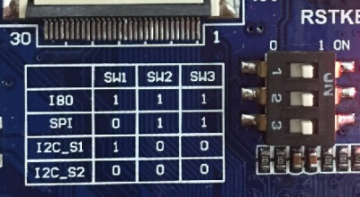
3) Display with demo code
You can download the demo code here
Open project and change set the interface to I80.
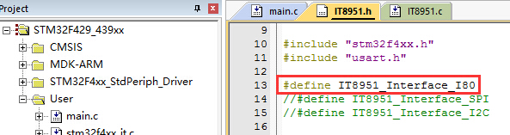

Display pictures
For easy porting our demo code, we display picture with data matrix instead of file system.
We should first convert BMP picture to data matrix (arrays), and use it in demo code.
1) Prepare a BMP image, resize the picture to 1200*825 (the resolution of this e-Paper)
2) Open BMP convert software, Click File->Open..-> to open the picture as below:
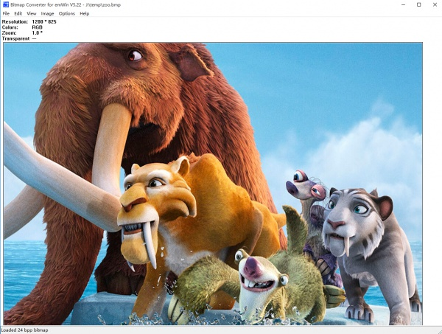
3) Click Image -> Convert to ->Gray256(8 BPP)
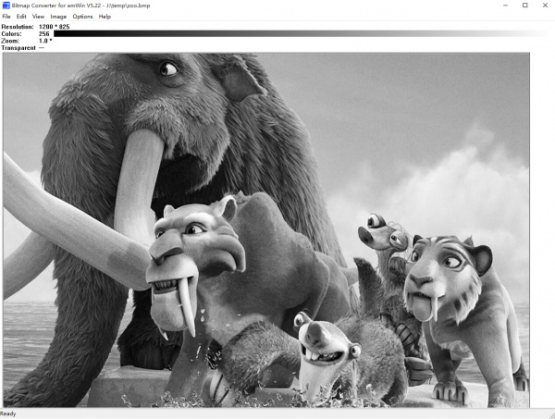
4) Click File ->Save As... ->Choose "C" bitmap file (*.c) -> input file name and click Save.
5) Choose 8 bit per pixel, click OK. A C file will be saved to your PC
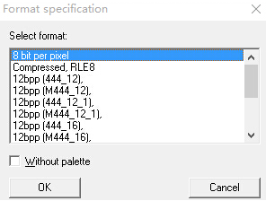

- Add the C file to keil project, detect unusable information
/*********************************************************************
* SEGGER Microcontroller GmbH & Co. KG *
* Solutions for real time microcontroller applications *
* www.segger.com *
**********************************************************************
* *
* C-file generated by *
* *
* Bitmap Converter for emWin V5.22. *
* Compiled Jul 4 2013, 12:18:24 *
* (c) 1998 - 2013 Segger Microcontroller GmbH && Co. KG *
* *
**********************************************************************
* *
* Source file: zoo *
* Dimensions: 1200 * 825 *
* NumColors: 256 *
* *
**********************************************************************
*/
#include <stdlib.h>
#include "GUI.h"
#ifndef GUI_CONST_STORAGE
#define GUI_CONST_STORAGE const#endif
extern GUI_CONST_STORAGE GUI_BITMAP bmzoo;
/*********************************************************************
*
* Palette
*
* Description
* The following are the entries of the palette table.
* The entries are stored as a 32-bit values of which 24 bits are
* actually used according to the following bit mask: 0xBBGGRR
*
* The lower 8 bits represent the Red component.
* The middle 8 bits represent the Green component.
* The highest 8 bits represent the Blue component.
*/static GUI_CONST_STORAGE GUI_COLOR _Colorszoo[] = {
0x000000, 0x010101, 0x020202, 0x030303,
0x040404, 0x050505, 0x060606, 0x070707,
0x080808, 0x090909, 0x0A0A0A, 0x0B0B0B,
0x0C0C0C, 0x0D0D0D, 0x0E0E0E, 0x0F0F0F,
0x101010, 0x111111, 0x121212, 0x131313,
0x141414, 0x151515, 0x161616, 0x171717,
0x181818, 0x191919, 0x1A1A1A, 0x1B1B1B,
0x1C1C1C, 0x1D1D1D, 0x1E1E1E, 0x1F1F1F,
0x202020, 0x212121, 0x222222, 0x232323,
0x242424, 0x252525, 0x262626, 0x272727,
0x282828, 0x292929, 0x2A2A2A, 0x2B2B2B,
0x2C2C2C, 0x2D2D2D, 0x2E2E2E, 0x2F2F2F,
0x303030, 0x313131, 0x323232, 0x333333,
0x343434, 0x353535, 0x363636, 0x373737,
0x383838, 0x393939, 0x3A3A3A, 0x3B3B3B,
0x3C3C3C, 0x3D3D3D, 0x3E3E3E, 0x3F3F3F,
0x404040, 0x414141, 0x424242, 0x434343,
0x444444, 0x454545, 0x464646, 0x474747,
0x484848, 0x494949, 0x4A4A4A, 0x4B4B4B,
0x4C4C4C, 0x4D4D4D, 0x4E4E4E, 0x4F4F4F,
0x505050, 0x515151, 0x525252, 0x535353,
0x545454, 0x555555, 0x565656, 0x575757,
0x585858, 0x595959, 0x5A5A5A, 0x5B5B5B,
0x5C5C5C, 0x5D5D5D, 0x5E5E5E, 0x5F5F5F,
0x606060, 0x616161, 0x626262, 0x636363,
0x646464, 0x656565, 0x666666, 0x676767,
0x686868, 0x696969, 0x6A6A6A, 0x6B6B6B,
0x6C6C6C, 0x6D6D6D, 0x6E6E6E, 0x6F6F6F,
0x707070, 0x717171, 0x727272, 0x737373,
0x747474, 0x757575, 0x767676, 0x777777,
0x787878, 0x797979, 0x7A7A7A, 0x7B7B7B,
0x7C7C7C, 0x7D7D7D, 0x7E7E7E, 0x7F7F7F,
0x808080, 0x818181, 0x828282, 0x838383,
0x848484, 0x858585, 0x868686, 0x878787,
0x888888, 0x898989, 0x8A8A8A, 0x8B8B8B,
0x8C8C8C, 0x8D8D8D, 0x8E8E8E, 0x8F8F8F,
0x909090, 0x919191, 0x929292, 0x939393,
0x949494, 0x959595, 0x969696, 0x979797,
0x989898, 0x999999, 0x9A9A9A, 0x9B9B9B,
0x9C9C9C, 0x9D9D9D, 0x9E9E9E, 0x9F9F9F,
0xA0A0A0, 0xA1A1A1, 0xA2A2A2, 0xA3A3A3,
0xA4A4A4, 0xA5A5A5, 0xA6A6A6, 0xA7A7A7,
0xA8A8A8, 0xA9A9A9, 0xAAAAAA, 0xABABAB,
0xACACAC, 0xADADAD, 0xAEAEAE, 0xAFAFAF,
0xB0B0B0, 0xB1B1B1, 0xB2B2B2, 0xB3B3B3,
0xB4B4B4, 0xB5B5B5, 0xB6B6B6, 0xB7B7B7,
0xB8B8B8, 0xB9B9B9, 0xBABABA, 0xBBBBBB,
0xBCBCBC, 0xBDBDBD, 0xBEBEBE, 0xBFBFBF,
0xC0C0C0, 0xC1C1C1, 0xC2C2C2, 0xC3C3C3,
0xC4C4C4, 0xC5C5C5, 0xC6C6C6, 0xC7C7C7,
0xC8C8C8, 0xC9C9C9, 0xCACACA, 0xCBCBCB,
0xCCCCCC, 0xCDCDCD, 0xCECECE, 0xCFCFCF,
0xD0D0D0, 0xD1D1D1, 0xD2D2D2, 0xD3D3D3,
0xD4D4D4, 0xD5D5D5, 0xD6D6D6, 0xD7D7D7,
0xD8D8D8, 0xD9D9D9, 0xDADADA, 0xDBDBDB,
0xDCDCDC, 0xDDDDDD, 0xDEDEDE, 0xDFDFDF,
0xE0E0E0, 0xE1E1E1, 0xE2E2E2, 0xE3E3E3,
0xE4E4E4, 0xE5E5E5, 0xE6E6E6, 0xE7E7E7,
0xE8E8E8, 0xE9E9E9, 0xEAEAEA, 0xEBEBEB,
0xECECEC, 0xEDEDED, 0xEEEEEE, 0xEFEFEF,
0xF0F0F0, 0xF1F1F1, 0xF2F2F2, 0xF3F3F3,
0xF4F4F4, 0xF5F5F5, 0xF6F6F6, 0xF7F7F7,
0xF8F8F8, 0xF9F9F9, 0xFAFAFA, 0xFBFBFB,
0xFCFCFC, 0xFDFDFD, 0xFEFEFE, 0xFFFFFF};
static GUI_CONST_STORAGE GUI_LOGPALETTE _Palzoo = {
256, // Number of entries
0, // No transparency
&_Colorszoo[0]};

GUI_CONST_STORAGE GUI_BITMAP bmzoo = {
1200, // xSize
825, // ySize
1200, // BytesPerLine
8, // BitsPerPixel
_aczoo, // Pointer to picture data (indices)
&_Palzoo // Pointer to palette};
7) Modify the codes
static GUI_CONST_STORAGE unsigned char _aczoo[] = {
to this one. (You can change the name of the array to every one you like)

const unsigned char zoo_1200_825[] = {
8) Modify related codes in IT8951.C as below
extern const unsigned char zoo_1200_825[];void IT8951DisplayExample3(){
IT8951LdImgInfo stLdImgInfo;
IT8951AreaImgInfo stAreaImgInfo;
TWord width = gstI80DevInfo.usPanelW;
TWord high = gstI80DevInfo.usPanelH;
TDWord i;

for (i = 0;i < width*high;i++)
{
gpFrameBuf[i] = zoo_1200_825[i];
}

IT8951WaitForDisplayReady();

//Setting Load image information
stLdImgInfo.ulStartFBAddr = (TDWord)gpFrameBuf;
stLdImgInfo.usEndianType = IT8951_LDIMG_L_ENDIAN;
stLdImgInfo.usPixelFormat = IT8951_8BPP;
stLdImgInfo.usRotate = IT8951_ROTATE_0;
stLdImgInfo.ulImgBufBaseAddr = gulImgBufAddr;
//Set Load Area
stAreaImgInfo.usX = 0;
stAreaImgInfo.usY = 0;
stAreaImgInfo.usWidth = width;
stAreaImgInfo.usHeight = high;

IT8951HostAreaPackedPixelWrite(&stLdImgInfo, &stAreaImgInfo);//Display function 2
IT8951DisplayArea(0,0, gstI80DevInfo.usPanelW, gstI80DevInfo.usPanelH, 2);}

