BT5.0 Audio PRO
Mini Bluetooth 5.0 MP3 Decoder Board Audio Receiver MP3 Lossless Player Wireless Stereo Music Amplifier Module
Lithium battery charging Incoming call
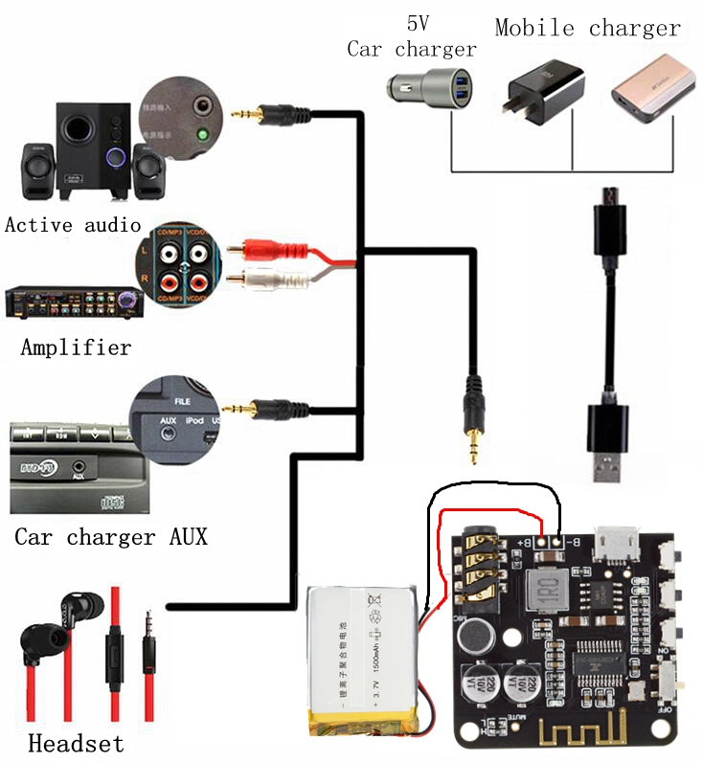

BT5.0 Audio PRO continues the excellent basic functions of M28 (long-distance transmission, Bluetooth 5.0 backward compatible, lossless sound quality, etc.), and adds more user-friendly performance, as follows:

Charge while putting:
This product has a circuit of charging and discharging, which can directly charge the battery through the USB power supply, and Bluetooth can continue to work normally during the charging process, and truly realize the function of charging and discharging. Solve the pain point that some products can not be used during the charging process.
When powered by USB alone: The red light flashes, indicating that the power supply is normal.
When powered by a separate battery: The yellow light is always on, indicating that the battery power supply is normal; the yellow light flashes, indicating that the battery is low.
When the USB and battery are connected at the same time: The red light flashes to indicate that the battery is charging; the red light always indicates that the battery is fully charged.
(Note that if the USB input is suddenly disconnected during the charging and discharging process, there will be a few seconds of interruption due to the charge and discharge mode switching at this time, after which Bluetooth will automatically restart, automatically connect and maintain the previous playback state)
Incoming voice call function:
After the Bluetooth is connected, turn on the call audio mode in the Bluetooth settings. If the phone calls, you can answer or hang up the phone through the PLAY/STOP button. You can choose to send from the microphone of the original headset (provided that the headset has a call function, which is a 4-segment type) or from the onboard microphone (default), see the function description for details.

When the computer sound card is used:
Tin the pads in the two boxes corresponding to the Sound Card on the back of the module, and then connect it to the USB interface of the computer through the USB cable, which can be used as a sound card. That is, the sound played by the computer is output through the audio interface of the module. See function description for details. (Not enabled by default)

Product Size:
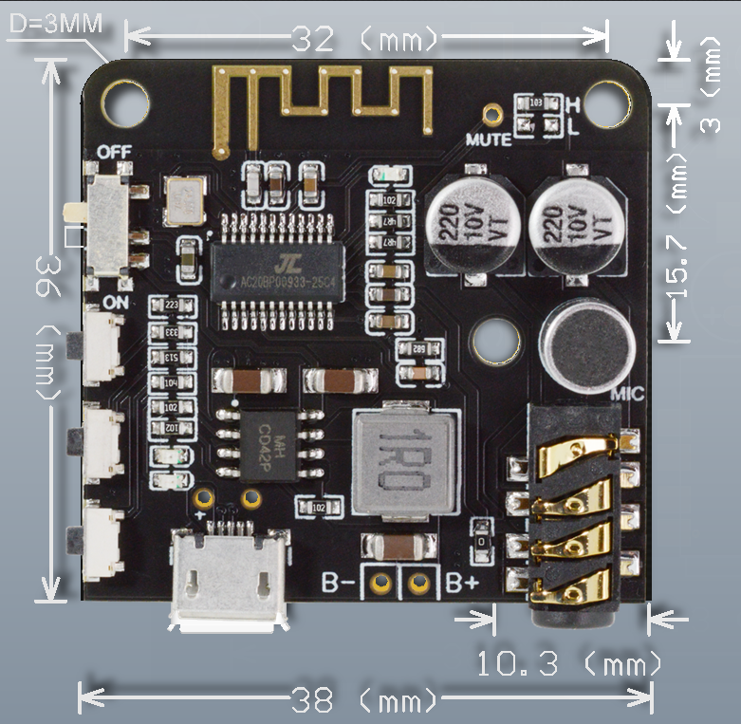

Product Features:
